CareSync Chai For Life
BetterWorld Master Campaign Build Sheet
Harvest Heart Hub | English and Spanish campaign copy | October 5, 2026
Prepared for Ken Sternfeld and the BetterWorld implementation team. Use this sheet to create campaign drafts, confirm each receiving organization, and return verified links for launch. It includes page copy, giving levels, buttons, donor records and acceptance checks.
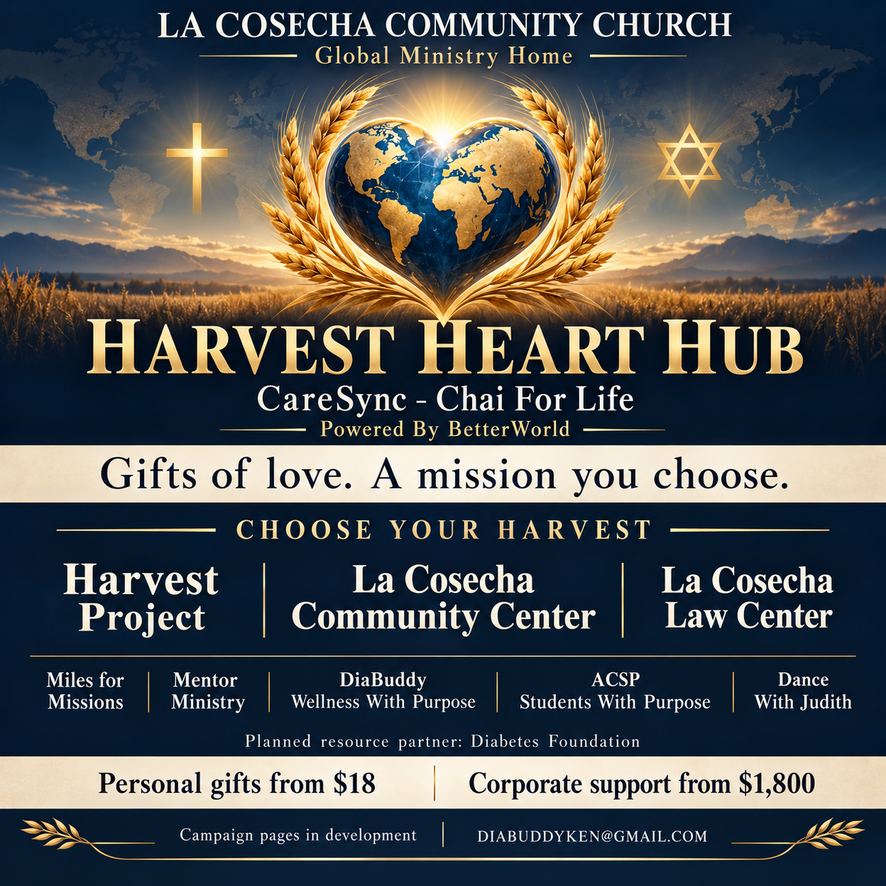
Account established by Ken; campaign pages remain in development. This handoff does not indicate that any fundraiser has been published. BetterWorld is the selected platform; the brand wording does not establish a signed partnership.

Campaign structure and donor journey
Build one central Harvest Heart Hub that directs each supporter to a clearly named mission and its correct receiving organization. A mission selection must lead to the appropriate campaign; a checkout question alone must not be used as a substitute for payment routing.
Order | Page or block | Action
1 | Harvest Heart Hub | Choose English or Español; show the supplied hero and mission cards.
2 | Choose Your Harvest / Elige tu misión | Explore three primary destinations and five supporting missions.
3 | Mission page | Read its purpose, receiving organization and dated progress.
4 | Choose Your Gift / Elige tu contribución | Select personal or corporate giving, amount and frequency.
5 | Checkout | Confirm campaign, recipient, frequency and total.
6 | Thank you / Gracias | Show acknowledgment, update choice and sharing options.

Page map and internal identifiers
ID | Page title | Initial release
HUB | Harvest Heart Hub | Central entry; link only to verified giving campaigns.
HARVEST | Harvest Project | Proposed first launch.
COMMUNITY | La Cosecha Community Center | Information first; funded activities to confirm.
LAW | La Cosecha Law Center | Proposed first launch.
MILES | Miles for Missions | Proposed first launch.
MENTOR | Faith & Pharmacy at The Mentor Ministry | Free resources; giving recipient to confirm.
WELLNESS | DiaBuddy Wellness With Purpose | Sponsorship scope and recipient to confirm.
ACSP | ACSP Students With Purpose | Student support activity and recipient to confirm.
DANCE | Dance With Judith | Future arts support; beneficiary and permission to confirm.
CORPORATE | Corporate Partners With Purpose | Mission-specific giving or contact pathway.
These IDs are implementation labels, not public URLs. If BetterWorld cannot host the complete central layout, use a branded entry page on PharmD Concierge linking to the individual BetterWorld campaigns. Return one stable public Hub URL.

Hub landing page copy

English
Page title: Harvest Heart Hub
Identity: CareSync – Chai For Life | Powered By BetterWorld
Ministry line: La Cosecha Community Church | Global Ministry Home
Headline: Gifts of love. A mission you choose.
Welcome: Welcome to Harvest Heart Hub, the giving center for CareSync – Chai For Life. Choose the mission closest to your heart and learn what your gift will support and who will receive it. CHAI means life. Personal giving begins at $18; corporate support begins at $1,800. Every gift is voluntary. Mentor Ministry books, Bible study guides and programs remain free.

Español
Título: Harvest Heart Hub | Centro de generosidad
Identidad: CareSync – Chai For Life | Impulsado por BetterWorld
Hogar ministerial: La Cosecha Community Church | Hogar ministerial global
Encabezado: Regalos de amor. Una misión que tú eliges.
Bienvenida: Bienvenido a Harvest Heart Hub, el centro de generosidad de CareSync – Chai For Life. Elige la misión más cercana a tu corazón y conoce qué apoyará tu contribución y quién la recibirá. CHAI significa vida. Las contribuciones personales comienzan en $18; el apoyo corporativo comienza en $1,800. Cada contribución es voluntaria. Los libros, las guías de estudio bíblico y los programas del Ministerio de Mentoría siguen siendo gratuitos.

Buttons and display order
English | Español | Destination
Choose Your Harvest | Elige tu misión | Mission cards on this page.
Give a Gift of Love | Comparte un regalo de amor | Mission selection before checkout.
Corporate Partners With Purpose | Socios corporativos con propósito | Corporate page.
Explore Free Ministry Resources | Explora los recursos ministeriales gratuitos | Verified free Mentor Ministry resource page.
Learn More | Conoce más | Information page for a mission not yet accepting gifts.
Primary cards: Harvest Project, La Cosecha Community Center, La Cosecha Law Center. Supporting cards: Miles for Missions, Mentor Ministry, DiaBuddy Wellness With Purpose, ACSP Students With Purpose, Dance With Judith. Place Diabetes Foundation in a separate planned resource-partner block, outside the giving selector.

Giving levels and form settings
Use exactly seven suggested personal amounts and seven suggested corporate amounts. The shared $1,800 level connects the ladders. Custom amounts may be offered alongside the seven suggestions. Amounts are in US dollars.
Level | Personal gift | Corporate gift
1 | $18 | $1,800
2 | $36 | $3,600
3 | $54 | $7,200
4 | $180 | $18,000
5 | $360 | $36,000
6 | $540 | $72,000
7 | $1,800 | $180,000

Personal giving
English: Choose a CHAI gift. Give once or monthly, in the amount that feels right for you. Each gift supports the mission you select.
Español: Elige una contribución CHAI. Contribuye una vez o cada mes, con el monto que sea adecuado para ti. Cada contribución apoya la misión que eliges.
Frequency labels: Give once / Contribución única; Give monthly / Contribución mensual. Recommended default: one-time giving, with an explicit donor selection for monthly giving. Show “per month / por mes” whenever monthly giving is selected.

Corporate giving
English: Bring your organization’s heart to the harvest. Choose a mission and one of seven corporate CHAI levels, beginning at $1,800.
Español: Comparte el corazón de tu organización con la cosecha. Elige una misión y uno de los siete niveles corporativos CHAI, desde $1,800.
Default corporate frequency: one-time. Arrange recurring institutional commitments separately when recipient and terms are defined. Confirm with BetterWorld how large gifts will be processed; show a contact option if an amount cannot be completed through the online form.

Settings requested from BetterWorld
Configure the seven suggestions, optional custom amount, explicit frequency, campaign identity, recipient identity, language route and acknowledgment. If a native form cannot show all seven suggestions, propose an equivalent layout that preserves them without creating additional tiers.
Tier labels identify contribution amounts. They do not promise naming rights, advertising benefits, specific service quantities or guaranteed outcomes. The conference’s $180 / $360 / $540 sponsorship offers remain separate.

Mission page copy 1 and 2

Harvest Project | HARVEST
Spanish title: Proyecto Harvest
English: Help grow the building vision for La Cosecha Community Church. Your gift supports the approved church building fund and its documented project needs. Follow this page for dated milestones and progress shared by the project team.
Español: Ayuda a desarrollar la visión de construcción de La Cosecha Community Church. Tu contribución apoya el fondo de construcción aprobado de la iglesia y las necesidades documentadas del proyecto. Consulta esta página para conocer los avances con fecha que comparta el equipo.
Giving button after activation: Give to the Harvest Project / Contribuye al Proyecto Harvest
Before activation: Confirm the church’s exact receiving entity, building-fund designation, current approved goal, project budget and reporting owner. Do not publish a dollar goal until it is confirmed.
Image direction: Use the hero or an authorized building vision image. Label any rendering as a concept; add approved location and milestone photographs when available.

La Cosecha Community Center | COMMUNITY
Spanish title: Centro Comunitario La Cosecha
English: Help create opportunities for fellowship, learning and community connection. This initiative will present approved community activities, their supported needs and the organization responsible for delivering them.
Español: Ayuda a crear oportunidades de convivencia, aprendizaje y conexión comunitaria. Esta iniciativa presentará actividades comunitarias aprobadas, sus necesidades y la organización responsable de realizarlas.
Giving button after activation: Support Community Programs / Apoya los programas comunitarios
Before activation: Confirm whether this is a church program or separate entity, identify the funded activities and costs, and distinguish programming support from the Harvest building fund.
Image direction: Use an authorized community gathering photo or approved program illustration; show the activity rather than implying a completed facility.

Mission page copy 3 and 4

La Cosecha Law Center | LAW
Spanish title: La Cosecha Law Center
English: Support the authorized community work of La Cosecha Law Center. Explore the specific services and outreach activities approved for this campaign and see which receiving organization will administer your gift.
Español: Apoya el trabajo comunitario autorizado de La Cosecha Law Center. Conoce los servicios y las actividades de alcance aprobados para esta campaña y la organización que administrará tu contribución.
Giving button after activation: Support the Law Center / Apoya a La Cosecha Law Center
Before activation: Obtain the Law Center’s approved campaign purpose, legal receiving name, payment connection and acknowledgment wording. Keep donations separate from legal-service inquiries and vendor sponsorship purchases.
Image direction: Use its authorized logo and an approved community-service image. Avoid client case details.

Miles for Missions | MILES
Spanish title: Millas para Misiones
English: Help support approved ministry travel and service through Miles for Missions. Each campaign update will identify the mission, supported travel or service needs, and the team responsible for carrying the work forward.
Español: Ayuda a apoyar viajes y servicio ministerial aprobados mediante Millas para Misiones. Cada actualización identificará la misión, las necesidades de viaje o servicio y el equipo responsable de realizar la labor.
Giving button after activation: Give to Miles for Missions / Contribuye a Millas para Misiones
Before activation: Confirm the church or other receiving entity, designated mission fund, trip or service purpose, budget and update owner. Do not imply gifts purchase travel rewards or airline miles.
Image direction: Use approved mission travel or service images and name the location only when confirmed.

Mission page copy 5 and 6

Faith & Pharmacy at The Mentor Ministry | MENTOR
Spanish title: Fe y Farmacia en el Ministerio de Mentoría
English: Help sustain free access to Share The Moment, Bible study guides, prayer and mentoring programs. You are welcome to participate whether or not you give. Gifts are voluntary and support the approved ministry purpose described on this page.
Español: Ayuda a mantener el acceso gratuito a Share The Moment, las guías de estudio bíblico y los programas de oración y mentoría. Puedes participar contribuyas o no. Las contribuciones son voluntarias y apoyan el propósito ministerial aprobado que se describe en esta página.
Giving button after activation: Support Free Ministry Resources / Apoya los recursos ministeriales gratuitos
Before activation: Confirm the receiving and administering entity and whether gifts support resource delivery, Harvest building work, or another designated ministry purpose. State that purpose explicitly; no paid ministry membership.
Image direction: Use an authorized Share The Moment cover, Bible study image or existing ministry artwork. Include a separate free-resource button.

DiaBuddy Wellness With Purpose | WELLNESS
Spanish title: Bienestar DiaBuddy con propósito
English: Help support prevention education and defined access to wellness care. Our focus is to delay the onset and reduce the risk of type 2 diabetes through prevention. This campaign will identify the approved educational activity or care-access sponsorship your gift supports.
Español: Ayuda a apoyar la educación preventiva y el acceso definido a servicios de bienestar. Nuestro enfoque es retrasar la aparición y reducir el riesgo de diabetes tipo 2 mediante la prevención. Esta campaña identificará la actividad educativa o el apoyo de acceso a la atención que respalda tu contribución.
Giving button after activation: Support Wellness With Purpose / Apoya el bienestar con propósito
Before activation: Define recipient, eligibility, funded services, costs and delivery owner. DPP care-plan purchases remain separate at the existing $29/month offer; a donation does not enroll the donor in care.
Image direction: Use telehealth at home with families. Avoid pharmacy interiors and medication images. Do not claim a fixed health result or undocumentable dollar-to-impact ratio.

Mission page copy 7 and 8

ACSP Students With Purpose | ACSP
Spanish title: Estudiantes ACSP con propósito
English: Help create approved learning, mentoring and career-development opportunities for students through the Association of Concierge Service Providers. This campaign will explain the student activity being supported and how participation is selected.
Español: Ayuda a crear oportunidades aprobadas de aprendizaje, mentoría y desarrollo profesional para estudiantes mediante la Association of Concierge Service Providers. Esta campaña explicará la actividad estudiantil que se apoya y cómo se selecciona la participación.
Giving button after activation: Support Students With Purpose / Apoya a estudiantes con propósito
Before activation: Confirm recipient, student selection criteria, supported activity, budget and reporting owner. Donations remain separate from ACSP membership fees; do not promise student-debt repayment.
Image direction: Use authorized student mentoring or remote learning imagery and the approved ACSP mark.

Dance With Judith | DANCE
Spanish title: Dance With Judith | Danza con Judith
English: Celebrate movement, artistic expression and connection through Dance With Judith. A future arts-support campaign will describe the approved activity, its beneficiary and how gifts help make participation possible.
Español: Celebra el movimiento, la expresión artística y la conexión mediante Dance With Judith. Una futura campaña de apoyo artístico describirá la actividad aprobada, su beneficiario y cómo las contribuciones facilitan la participación.
Giving button after activation: Support Arts and Connection / Apoya el arte y la conexión
Before activation: Confirm Judith’s permission, receiving entity, rights to program materials, access criteria and supported costs. The planned $18/month service membership is separate from voluntary gifts.
Image direction: Use Judith’s approved portrait or licensed dance imagery. Do not publish third-party institutional marks without permission.

Corporate page and partner block

Corporate Partners With Purpose
English: Businesses, foundations, congregations and service organizations are invited to bring their values to life through a mission they choose. Select a corporate CHAI level from $1,800 to $180,000, review the receiving organization, and help support its approved work. Contact us to discuss a larger commitment or a defined sponsorship opportunity.
Español: Invitamos a empresas, fundaciones, congregaciones y organizaciones de servicio a expresar sus valores mediante una misión que elijan. Selecciona un nivel corporativo CHAI de $1,800 a $180,000, revisa la organización beneficiaria y ayuda a apoyar su labor aprobada. Contáctanos para conversar sobre un compromiso mayor o una oportunidad de patrocinio definida.
Buttons: Choose a Mission / Elige una misión; Discuss Corporate Support / Consulta sobre apoyo corporativo.
Contact: Ken Sternfeld, Registered Pharmacist. Founder and Chief DiaBuddy Officer, CareSync Concierge, LLC. DIABUDDYKEN@GMAIL.COM
Corporate inquiry fields: organization name, contact name, email, selected mission, proposed amount, preferred language and optional message. Request permission before listing any organization as a sponsor or publishing its logo. A conversation is not a confirmed contribution.

Diabetes Foundation resource block
English: Planned resource partner: Diabetes Foundation. We intend to include diabetes education and support resources in the Harvest Heart Hub. Any dedicated campaign benefiting the Foundation will be arranged with the organization before gifts are accepted.
Español: Socio de recursos previsto: Diabetes Foundation. Tenemos previsto incluir recursos de educación y apoyo sobre diabetes en Harvest Heart Hub. Cualquier campaña dedicada a beneficiar a la Fundación se coordinará con la organización antes de aceptar contribuciones.
Button: Learn About Resources / Conoce los recursos. Use an organization-approved resource URL. Do not route donations to the Foundation under a different campaign recipient or represent the planned relationship as a signed partnership.

Mission page information panel
Every active giving page must display the receiving organization’s exact name, supported purpose, one-time or monthly choices, contact, date of latest update and an approved goal if one exists. Show named need and progress before any monetary impact claim.
Suggested English panel labels: Your gift supports; Receiving organization; Latest update; Contact. Spanish: Tu contribución apoya; Organización beneficiaria; Última actualización; Contacto.

Checkout and donor records

Checkout copy
English: Please review your selected mission, receiving organization, gift amount, frequency and total before completing your contribution. Giving is voluntary. It is separate from free ministry participation, free conference registration and purchases of care plans or memberships.
Español: Revisa la misión elegida, la organización beneficiaria, el monto, la frecuencia y el total antes de completar tu contribución. Contribuir es voluntario. Es independiente de la participación ministerial gratuita, la inscripción gratuita a la conferencia y la compra de planes de atención o membresías.
Use the platform’s actual checkout totals and payment disclosures. Do not promise that all gross proceeds reach the beneficiary. The receiving organization must approve receipt and any applicable tax wording.

Requested record fields
Field | Use
Campaign ID and receiving entity | Required in reporting and reconciliation; derive from the campaign.
Name and email | Use the platform’s required receipt fields.
Amount, currency and frequency | Record the committed amount and actual transaction history.
Preferred language | Optional English / Español choice for follow-up.
Dedication | Optional in honor of / in memory of; avoid requesting private details.
Updates consent | Optional, separate and unchecked by default.
Corporate organization | Optional unless corporate support is chosen.
Gross, costs, net and payout | Track actual platform data; report unavailable fields separately.

Updates consent
English: Yes, I would like email updates about the mission I selected. I can unsubscribe at any time.
Español: Sí, deseo recibir por correo electrónico novedades sobre la misión que elegí. Puedo cancelar la suscripción en cualquier momento.
Ask BetterWorld to identify which fields, language routes and exports are supported natively. Keep health information, legal case details and prayer requests in their separate service pathways. Assign one reconciliation owner and recipient contact per campaign.

Acknowledgment and sharing copy

Thank you page
English: Thank you for sharing a gift of love. Your contribution supports the mission and receiving organization identified in your confirmation. Please keep your receipt. You can help grow the harvest by sharing this campaign with someone who cares about its purpose.
Español: Gracias por compartir un regalo de amor. Tu contribución apoya la misión y la organización beneficiaria indicadas en tu confirmación. Conserva tu recibo. Puedes ayudar a ampliar la cosecha compartiendo esta campaña con alguien que valore su propósito.
Buttons: Share the Love / Comparte el amor; Return to Harvest Heart Hub / Regresa a Harvest Heart Hub; Explore Free Resources / Explora los recursos gratuitos.

Acknowledgment email body
English: Thank you for supporting CareSync – Chai For Life through Harvest Heart Hub. Your receipt identifies your selected mission, receiving organization, contribution amount and frequency. We appreciate the heart behind your gift. If you chose to receive updates, we will share progress about the mission you selected. For program questions, contact DIABUDDYKEN@GMAIL.COM. With gratitude, Ken Sternfeld, Registered Pharmacist, Founder and Chief DiaBuddy Officer.
Español: Gracias por apoyar a CareSync – Chai For Life mediante Harvest Heart Hub. Tu recibo identifica la misión elegida, la organización beneficiaria, el monto y la frecuencia de tu contribución. Agradecemos el amor que inspira tu regalo. Si elegiste recibir novedades, compartiremos los avances de la misión seleccionada. Para consultas sobre el programa, escribe a DIABUDDYKEN@GMAIL.COM. Con gratitud, Ken Sternfeld, farmacéutico registrado, fundador y Chief DiaBuddy Officer.

Share message after campaign activation
English: Gifts of love. A mission you choose. Discover Harvest Heart Hub from CareSync – Chai For Life. Choose the mission closest to your heart. Personal gifts begin at $18; corporate support begins at $1,800. Explore the missions and giving options through the verified Hub link below.
Español: Regalos de amor. Una misión que tú eliges. Descubre Harvest Heart Hub de CareSync – Chai For Life. Elige la misión más cercana a tu corazón. Las contribuciones personales comienzan en $18; el apoyo corporativo comienza en $1,800. Explora las misiones y las opciones mediante el enlace verificado del centro que aparece abajo.
Append the verified public Hub URL only after activation. Generate a QR code from that same stable URL; test on a phone before adding it to email, WhatsApp or social assets.

Visual assets and implementation handoff

Visual specification
Use the supplied navy-and-gold Harvest Heart Hub image as the primary visual. Preserve the cross, Star of David, globe heart and harvest imagery. Place all essential page text and buttons in native readable text outside the image so mobile visitors can read and act.
Suggested palette from the image: midnight navy #071D31, gold #DDB25F, warm ivory #F6E8CC. Use high-contrast text and visible button labels. Keep English and Spanish in clearly labeled blocks; avoid narrow side-by-side columns on phones.
Hero alt text: Gold globe shaped like a heart framed by wheat, with a cross and Star of David, presenting Harvest Heart Hub and La Cosecha Community Church as the global ministry home.
The supplied image says “Campaign pages in development.” Retain that status during preparation. Before live giving begins, replace that status text in a separate approved launch asset. Confirm the selected-platform attribution with the implementation team.

Requested implementation sequence
Step | Owner | Deliverable
Confirm mission records | Ken and recipient leads | Exact receiving names, purposes, goals, permissions and contacts.
Confirm account routing | BetterWorld with recipients | Written account and payment configuration for each entity.
Build drafts | BetterWorld implementer | Hub layout, first three campaigns, bilingual copy and both ladders.
Review drafts | Ken and recipient leads | Correct recipient, purpose, artwork, amounts and acknowledgment.
Verify checkout | Implementer and recipient | Preview or supported test verifies one-time and monthly routes; no unsolicited live charge.
Prepare launch links | Implementer | Public Hub URL, campaign URLs and supported form embed code.
Release and monitor | Ken and campaign owners | Share only activated missions; reconcile weekly during launch.
Requested review window: October 5–9. Requested configuration and verification window: October 10–15. Intended introduction: Renew Your Vows, October 16–18, 2026, 10 AM–5 PM Eastern daily, free admission. These are proposed work windows, not a confirmed BetterWorld commitment. Introduce the program as in development if giving routes are not ready.

Acceptance checks and source record

Return package from the implementation team
Return the stable Hub URL; all active mission URLs; exact receiving organizations; screenshots or previews of English and Spanish pages; one-time and monthly settings; corporate processing pathway; approved receipt copy; donor export sample; recipient routing confirmation; and any form embed code supported for the planned placement.

Launch acceptance checks
• Each mission button opens the matching campaign and names its verified recipient before checkout.
• Exactly seven personal and seven corporate suggestions appear; $1,800 belongs to both ladders.
• Monthly frequency is explicit; one-time giving remains available; totals and optional charges are clear.
• Unready initiatives show information or contact buttons rather than active donation buttons.
• Mentor Ministry resources and all three conference days remain free; purchases follow separate pathways.
• English and Spanish copy is readable on a phone; essential text is not trapped inside the hero graphic.
• Thank-you messages, contact details, consent choice and actual donor exports match the approved campaign.
• The Hub URL and QR destination work; there are no invented URLs, recipient names or published goal amounts.

Basis and platform references
Program source: CareSync_Chai_For_Life_Harvest_Heart_Hub.pdf, version 2, October 5, 2026; Harvest_Heart_Hub_Presentation_EN_ES.pdf, October 5, 2026. Supplied Harvest Heart Hub image reviewed for brand, mission names and development status. This sheet extends those materials into proposed implementation copy.
BetterWorld documentation checked October 5, 2026. Its On-Behalf-Of guidance describes direct transfers to the connected nonprofit after setup. Its donation-form and donation-page documentation describes suggested amounts, recurring giving, embedding and custom questions. Ask the implementation team to confirm the account-specific setup and bilingual presentation before release.
https://help.betterworld.org/en/articles/8840558-how-to-sign-up-to-raise-funds-on-behalf-of-another-organization
https://betterworld.org/fundraising-software/donation-forms/
https://betterworld.org/fundraising-software/donations/
Program contact: Ken Sternfeld, Registered Pharmacist | CareSync Concierge, LLC | DIABUDDYKEN@GMAIL.COM

